Kyushu Institute of Technology

Department of Applied Science for Integrated System Engineering







**BIRDS-4 Project**

**Vibration Test Report (GuaraniSat-1)**

Kyushu Institute of Technology

Laboratory of Lean Satellite Enterprises and In-Orbit Experiments



|  |  |  |  |
| --- | --- | --- | --- |
| **Date** | **Revision Number** | **Writer** | **Annotations** |
| 2020/06/19 | 1 | Yigit Cay | Initial Release |
| 2020/08/16 | 2 | Yigit Cay | Adding new test results |
|  |  |  |  |

**Contents**

[List of Acronyms and Abbreviations 1](#_Toc534940685)

[1. Introduction 2](#_Toc534940686)

[2. Referenced Documentation 2](#_Toc534940687)

[3. Test Purpose 2](#_Toc534940688)

[4. Test article(s) 3](#_Toc534940689)

[5. Acceleration measurement point 3](#_Toc534940690)

[6. Test Facility Equipment 5](#_Toc534940691)

[7. Test Description 6](#_Toc534940692)

[8. Test Schedule 11](#_Toc534940693)

[9. Test Result 12](#_Toc534940694)

[10. Acquired data 16](#_Toc534940695)

[11. Conclusion 18](#_Toc534940696)

**List of Acronyms and Abbreviations**

|  |  |  |  |  |
| --- | --- | --- | --- | --- |
| **A** |  |  | **P** |  |
| AMP | Charge Amplifier |  | PC | Personal Computer |
| AT | Acceptance Test |  | PMB | Pillar Mother Board |
| ATV | Automatic Transfer Vehicle |  |  |  |
| **B** |  |  | **R** |  |
| BAT | Battery |  | RAS | Requirement Allocation Sheet |
| **C** |  |  |  |  |
| CH | Channel |  | **S** |  |
| CAM | Camera |  | STM | Structure and Thermal model |
| **D** |  |  | STR | Structure team |
| DAQ  DR | Data Acquisition System  Design Requirements |  | SVBL | Satellite Venture Business Laboratory |
| Dir | Direction |  | SpX | Space X |
| **E** |  |  |  |  |
| EM | Engineering Model |  |  |  |
|  |  |  |  |  |
| **F** |  |  |  |  | |
| FFT | Fast Fourier Transform |  |  |  |
| FM  **G** | Flight Model |  |  |  |
| Go-p | G zero to peak |  |  |  |
| Grms | G Root mean square |  |  |  |
|  |  |  |  |  |
| **H** |  |  |  |  |
| HTV | HII Transfer Vehicle |  |  |  |
|  |  |  |  |  |
| **J** |  |  |  |  |
| JEM | Japanese Experimental Module |  |  |  |
|  |  |  |  |  |

1. Introduction

This report is applied to a vibration test for GuaraniSat-1 (BIRDS-4).

The aim of the test is to demonstrate that the test article can withstand mechanical vibration when excited with acceleration levels induced by launch vehicles which includes HTV-X, Dragon and Cygnus by adding the minimum workmanship level (MWL).

1. Referenced Documentation
   1. JX-ESPC-101132-D　‘JEM Payload Accommodation Handbook Vol.8 Small Satellite Deployment Interface Control Document’, May 2020.
   2. Torque Chart ‘Maryland Metrics Torque Chart’, Retrieved May, 2016. Link: <https://mdmetric.com/tech/torqcht1a.pdf>
   3. SSP52005 ‘Payload Flight Equipment Requirements and Guidelines for Safety-Critical Structures’, December 2002.
   4. NASA-STD-7001 ‘Payload Vibroacoustic Test Criteria’, November 2017
2. Test Purpose

**3.1. Overall test description**

The purpose of this test is to evaluate the impact of vibration by launch vehicle on GuaraniSat-1 of BIRDS-4 CubeSat structure.

**3.2. Success Criteria**

The success of the vibration test will be determined based on the following criteria;

1. Shift in Natural Frequency: A significant shift in natural frequency indicates *workmanship failure* (loose components on/in the structure). Any broken parts in the primary structure shall be judged as a *failure in design.*
2. Torque Mark Shift: When observed visually, there should be no shift in torque marks on the screws on the test article after each test. Any shift in torque mark shows a *workmanship failure* in setting the required torque before testing
3. Fracture Critical Parts:
4. All external fasteners and fasteners holding the main structure shall not be loose after vibration
5. Glass components (including solar cells and camera lens) shall not be broken after vibration
6. Deployable Components

The deployable UHF and VHF dipole antennas shall not deploy during vibration.

1. Radio Interference

Satellite shall not broadcast radio (CW or HK) during vibration. Radio is set to CW frequency throughout the test to confirm no broadcast is received from satellite.

1. Satellite Function

Satellite functional test shall be conducted before and after vibration tests. Satellite should function the same after the vibration test as before the test. Refer to “20\_ BIRDS4-FCR-01”

1. Test article(s)

**Table 4-1 Test articles**

|  |  |  |  |  |  |
| --- | --- | --- | --- | --- | --- |
|  | **Article name** | **Number** | **Manufacturer** | **Mass (kg)** | **Dimension (mm)** |
| **1** | BIRDS-4 FM / 001U (Tsuru) | 1 | HMD | 1.30 | 100 (L) × 100 (W) × 113.5 (H) |
| **2** | BIRDS-4 FM / 001R (Maya-2) | 1 | HMD | 1.30 | 100 (L) × 100 (W) × 113.5 (H) |
| **3** | BIRDS-4 FM / 001N (GuaraniSat-1) | 1 | HMD | 1.31 | 100 (L) × 100 (W) × 113.5 (H) |
| **4** | 3U Pod | 1 |  | 4.62 |  |

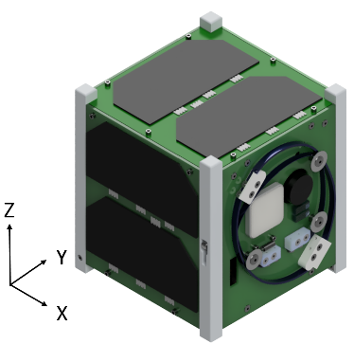 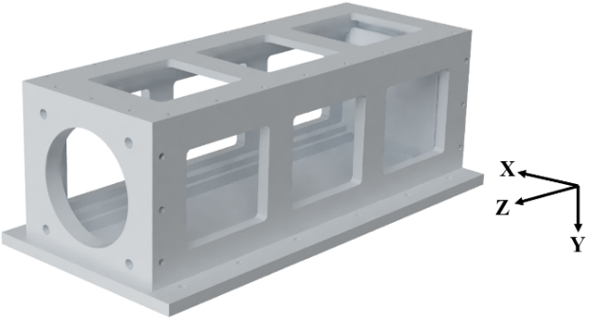

(a) (b)

113.6±0.05 m

Figure 4-1 Test Articles: (a) BIRDS-4 FM and (b) 3U POD

1. Acceleration measurement point

The acceleration measurement points are shown in Figures 5-1 to 5-4 and Table 5-1.

“Ch.〇” are acceleration measurement points for data acquisition.

“Control point 〇 (C.P.〇)” are acceleration measurement points for average value control for the vibration machine.

**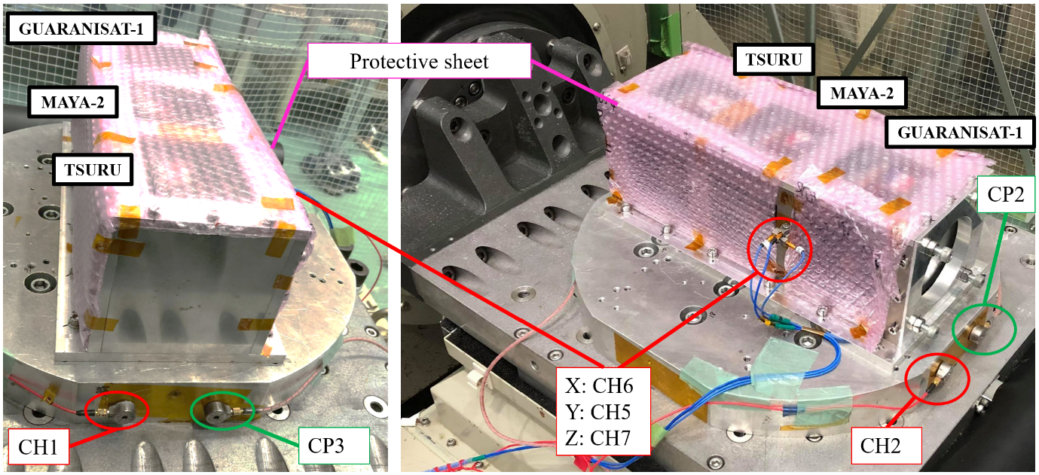**

**Figure 5-1 Acceleration measurement points of POD and FMs in front (left) and back side (right) of the vibration machine. Protective sheet is used in between the tests to prevent the physical damage on the FMs.**

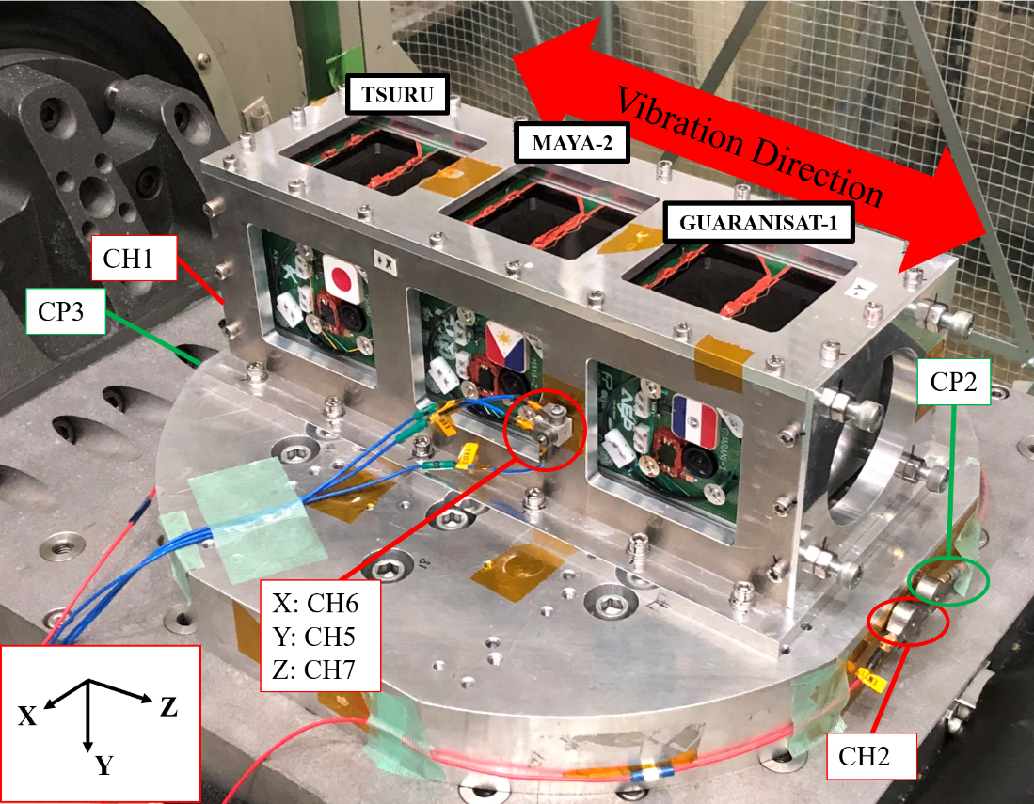

**Figure 5-2 Acceleration measurement points of jig (Z-axis vibration)**

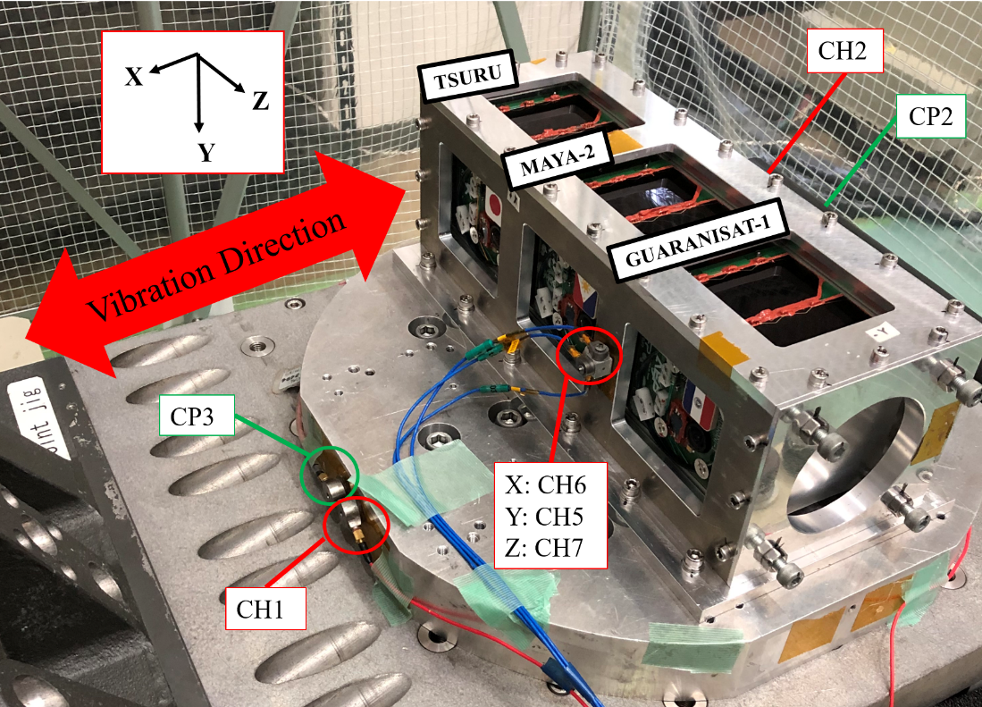

**Figure 5-3 Acceleration measurement points of jig (X-axis vibration)**

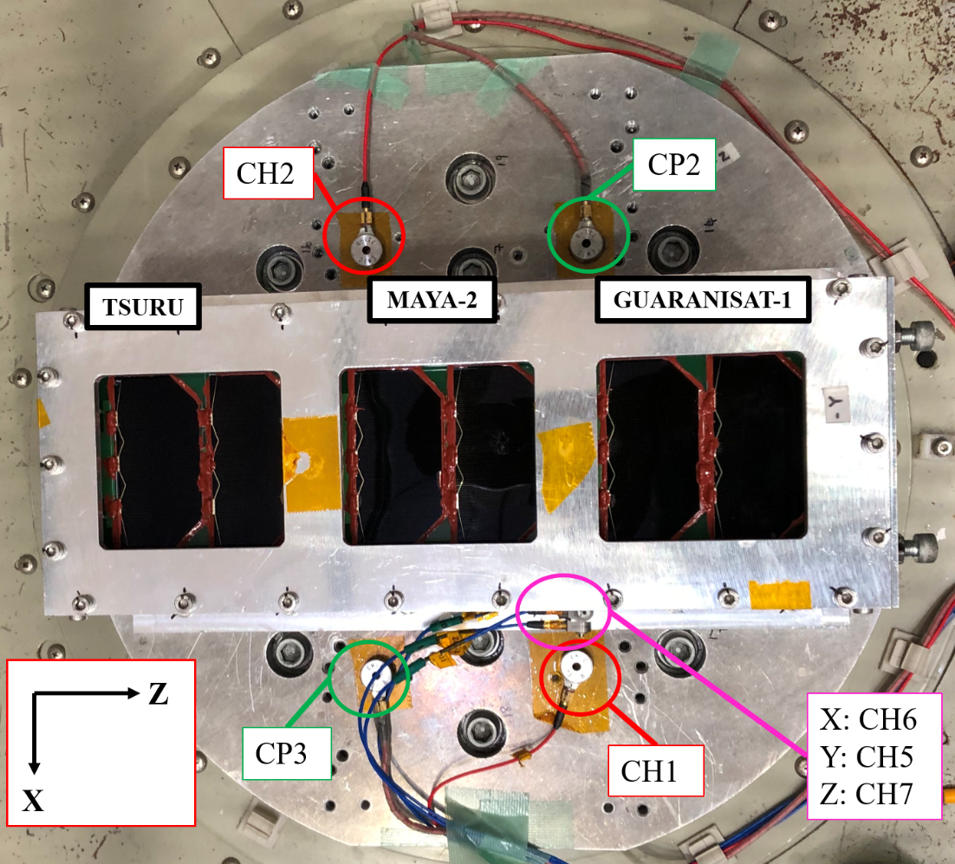

**Figure 5-4 Acceleration measurements point of jig (Y-axis vibration)**

**Table 5-1 Acceleration measurement point**

|  |  |  |  |
| --- | --- | --- | --- |
| **Ch** | **Axis** | **Mounting position**  **(Axis of the Pod)** | **Channel/Accelerometer number** |
| 6 | X | ＋X side plane of POD | tt02 |
| 5 | Y | tt01 |
| 7 | Z | tt03 |
| 1 | - | Jig | EM11 |
| 2 | - | Jig | EM14 |
| C.P. 2 | | Jig | EM12 |
| C.P. 3 | | Jig | EM15 |

1. Test Facility Equipment

* Test center name and address

Center for Nanosatellite Testing (CeNT)

Laboratory of Lean Satellite Enterprises and In-Orbit Experiments

Kyushu Institute of Technology

1-1 Sensui, Tobata, Kitakyushu, 804-8550 Fukuoka, Japan

* Test facility

**Table 6-1 Vibration testing system specification**

|  |  |  |  |  |
| --- | --- | --- | --- | --- |
| No. | Items | Specification | | |
| 1 | Type | F-35000BD/LA36AP(made by EMIC) | | |
| 2 | Exciting Force | Sine | | 35.0kN |
| Random | | 28.0kN |
| Shock | | 87.5kN |
| 3 | No-load maximum acceleration | Vertical | Sine | 1060.0 m/s^2 |
| Shock | 1470.0 m/s^2 (0-p) |
| Horizontal | Sine | 460.5m/s^2 |
| Shock | 1151.3 m/s^2 (0-p) |
| 4 | Maximum loading mass | Vertical | | 400kg |
| Horizontal | | 500kg |
| 5 | Horizontal vibration table size | 50cm x 50 cm | | |
| 6 | Power | 49.0kVA | | |

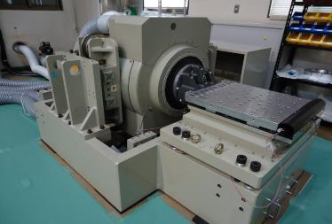

**Figure 6-1 Vibration Test Machine**

The Figure 6-1 is an image of the vibration test machine used for the vibration test.

1. Test Description
   1. **Actual Test flow**

|  |  |  |  |  |  |  |  |  |  |  |
| --- | --- | --- | --- | --- | --- | --- | --- | --- | --- | --- |
|  | **01 Functional Test\*** |  |  |  |  |  |  |  |  |  |
|  | **↓** |  |  |  |  |  |  |  |  |  |
|  | **02 Preparation** |  |  |  | **06 Axis change** |  |  |  | **10 Axis change** |  |
|  | **↓** |  |  |  | **↓** |  |  |  | **↓** |  |
| **Z axis** | |  |  | **X axis** | |  |  | **Y axis** | |  |
|  | **03 Modal** |  | → |  | **07 Modal** |  | → |  | **11 Modal** |  |
|  | **↓** |  |  |  | **↓** |  |  |  | **↓** |  |
|  | **04 Random AT+MWL** |  |  |  | **08 Random AT+MWL** |  |  |  | **12 Random AT+MWL** |  |
|  | **↓** |  |  |  | **↓** |  |  |  | **↓** |  |
|  | **05 Modal** |  |  |  | **09 Modal** |  |  |  | **13 Modal** |  |
|  |  |  |  |  |  |  |  |  |  |  |
|  |  |  |  |  |  |  |  |  | **↓** |  |
|  |  |  |  |  |  |  |  |  | **14 Clean up** |  |
|  |  |  |  |  |  |  |  |  | **↓** |  |
|  |  |  |  |  |  |  |  |  | **15 Functional Test\*** |  |

**Figure 7.1-1 Test Flow**

Before the modal survey, visual inspection was conducted.

* 1. **Test set-up**

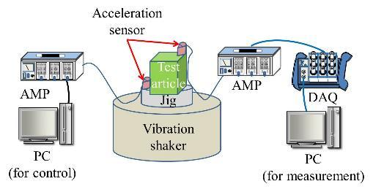

**Figure 7.2-1 Schematic of Test Equipment**

Table 7.2-1. Table shows the settings on the PC for control and measurement of data.

**Table 7.2-1 Setting of PC**

|  |  |  |  |
| --- | --- | --- | --- |
| **Vibration test type** | | **Modal survey** | **Random** |
| Vibration Profile | | Random | Random |
| Vibration parameters | Test type | Modal | Random |
| Frequency:  Min [Hz] | 20 | 20 |
| Frequency:  Max [Hz] | 2,000 | 2,000 |
| Setting of measuring:  Number of channels | 8 | 8 |
| Setting of measuring:  Measuring time [sec] | 50 | 50 |
| Setting of measuring:  Sampling rate [sample/sec] | 10,000 | 10,000 |
| Setting of analysis:  Number of FFT point | 16,384 | 16,384 |
| Setting of analysis:  G/V | 31.6 | 31.6 |
| Monitor (OSC)  Display time [sec] | 0.2 | 0.2 |
| Monitor (OSC)  Max value of voltage [V] | 0.5 | 2 |
| Vibration Machine control | Switch: Sine - Random | Random | Random |
| External level | Half | Max |
| AMP | G/V range of single sensor | 3.16 | 3.16 |
| G/V range of control sensor | 31.6 | 31.6 |

* 1. **Supporting analyses**

The analysis of the vibration response of the test article shall be computed using a MATLAB program.

* 1. **Test condition**

The test shall consist of:

* Modal survey

**Table 7.4-1. Modal survey test table**

|  |  |  |  |
| --- | --- | --- | --- |
| **MODAL SURVEY** | | | |
| **Direction** | **Frequency [Hz]** | **Acceleration [Grms]** | **Time [sec]** |
| X, Y, Z | 20~2000 | 0.5  (White Noise) | 60 |

* Random vibration test

The Random Acceleration Profile for the Test (Envelope) is as shown in Figure 7.4-2 derived from maximum PSD values of HTV-X, Dragon and Cygnus launch vehicles as shown in Table 7.4-2

**C:\Users\yibim\AppData\Local\Microsoft\Windows\INetCache\Content.Word\PSD_VAT_profiles_2.tif**

**Figure 7.4-1 AT Random vibration profiles for HTV-X, Dragon and Cygnus with MWL (Ref. JX-ESPC-101132-D and NASA-STD-7001 for MWL)**

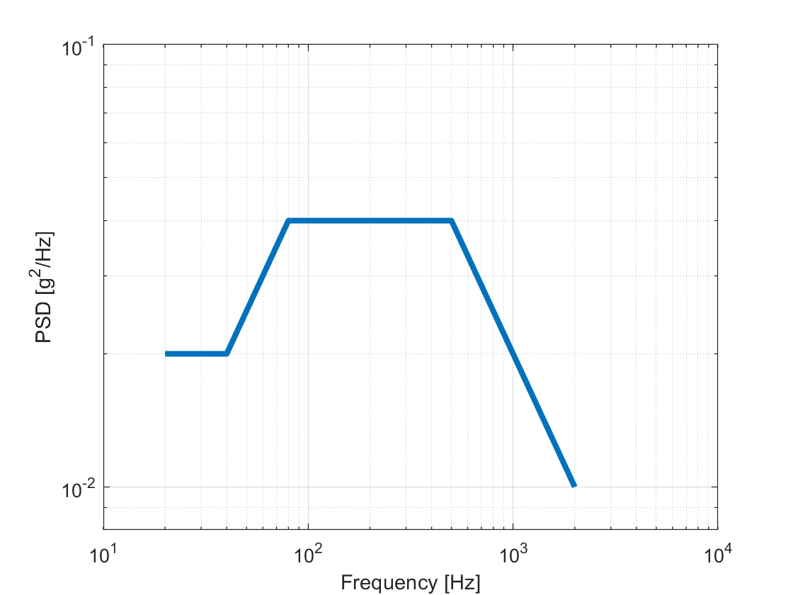

**Figure 7.4-2 Acceptance Test random vibration profile (PSD envelope)**

**Table 7.4-2 Random Vibration (AT) of Each Launch Vehicle, MWL and Max PSD (HTV-X, Dragon and Cygnus)**

|  |  |  |  |  |  |  |  |
| --- | --- | --- | --- | --- | --- | --- | --- |
| **HTV-X** | | **Dragon** | | **Cygnus** | | **MWL** | |
| *Freq. (Hz)* | *PSD (g2/Hz)* | *Freq. (Hz)* | *PSD (g2/Hz)* | *Freq. (Hz)* | *PSD (g2/Hz)* | *Freq. (Hz)* | *PSD (g2/Hz)* |
| 20 | 0.005 | 20 | 0.02 | 20 | 0.004 | 20 | 0.01 |
| 50 | 0.02 | 200 | 0.02 | 30 | 0.004 | 80 | 0.04 |
| 120 | 0.031 | 2000 | 0.001 | 70 | 0.015 | 500 | 0.04 |
| 230 | 0.031 |  |  | 150 | 0.015 | 2000 | 0.01 |
| 1000 | 0.0045 |  |  | 2000 | 0.0006 |  |  |
| 2000 | 0.0013 |  |  |  |  |  |  |
| Overall (Grms) | 4.05 | Overall (Grms) | 3.20 | Overall (Grms) | 2.44 | Overall (Grms) | 6.78 |
| Duration (s) | 60 | Duration (s) | 7.2 | Duration (s) | 60 | Duration (s) | 60 |

|  |  |
| --- | --- |
| **Envelope** | |
| *Freq. (Hz)* | *PSD (g2/Hz)* |
| 20 | 0.02 |
| 40 | 0.02 |
| 80 | 0.04 |
| 500 | 0.02 |
| 2000 | 0.02 |
| Overall (grms) | 6.79 |
| Duration (s) | 60 |

**Table 7.4-3. Random vibration test table**

|  |  |  |  |
| --- | --- | --- | --- |
| **RANDOM VIBRATION TEST** | | | |
| **Direction** | **Frequency [Hz]** | **Overall Acceleration [Grms]** | **Time [sec]** |
| X, Y, Z | 20~2000 | 6.79 | 60 |

1. Test Schedule

**Table 8-1 Test Schedule**

|  |  |  |
| --- | --- | --- |
| Date | Vibration axis | Test |
| 2020/08/11 | Z | 1. Modal |
| 2. Random AT |
| 3. Modal |
| X | 4. Modal |
| 5. Random AT |
| 6. Modal |
| Y | 7. Modal |
| 8. Random AT |
| 9. Modal |

1. Test Result
2. Shift in Natural Frequency: A significant shift in natural frequency indicates workmanship failure (loose components on/in the structure).
3. Torque Mark Shift: When observed visually, there should be no shift in torque marks on the screws on the test article after each test.
4. Fracture Critical Parts:
5. All external fasteners and fasteners holding the main structure shall not be loose after vibration
6. Glass components (including solar cells and camera lens) shall not be broken after vibration

Although it was confirmed by visual observation after the test, breakage was not observed in the main structure and the internal structure. The appearance before and after the test is shown in Table 9-1 for comparison.

**Table 9-1 External structure before and after vibration test**

|  |  |  |
| --- | --- | --- |
| **Panels** | **Before test** | **After test** |
| **+X** | 説明がありません | **C:\Users\yibim\AppData\Local\Packages\microsoft.windowscommunicationsapps_8wekyb3d8bbwe\LocalState\Files\S0\6\Attachments\IMG_4853[3832].jpg** |
| **-X** | 説明がありません | **C:\Users\yibim\AppData\Local\Packages\microsoft.windowscommunicationsapps_8wekyb3d8bbwe\LocalState\Files\S0\6\Attachments\IMG_4776[3615].jpg** |
| **+Z** | 説明がありません |  |
| **-Z** | 説明がありません | **C:\Users\yibim\AppData\Local\Packages\microsoft.windowscommunicationsapps_8wekyb3d8bbwe\LocalState\Files\S0\6\Attachments\IMG_4772[3607].jpg** |
| **+Y** | 説明がありません | **C:\Users\yibim\AppData\Local\Packages\microsoft.windowscommunicationsapps_8wekyb3d8bbwe\LocalState\Files\S0\6\Attachments\IMG_4775[3613].jpg** |
| **-Y** | 説明がありません |  |

1. Deployable Components: The Deployable Antenna shall not deploy during launch. The Deployable Antenna did not deploy during this vibration test.
2. Radio Interference: Satellite shall not broadcast radio (CW or HK) during vibration. Radio is set to CW frequency throughout the test to confirm no broadcast is received from satellite.

Satellite did not broadcast radio (CW or HK) during vibration.

1. Satellite Function: Satellite functional test shall be conducted before and after vibration tests. Satellite function after vibration tests should be the same as before tests.

Satellite function after vibration tests was the same as before tests.

1. Acquired data
2. Figures 10.1-1 to 10.1-2 show control data and excitation results of the exciter for the Z-axis.

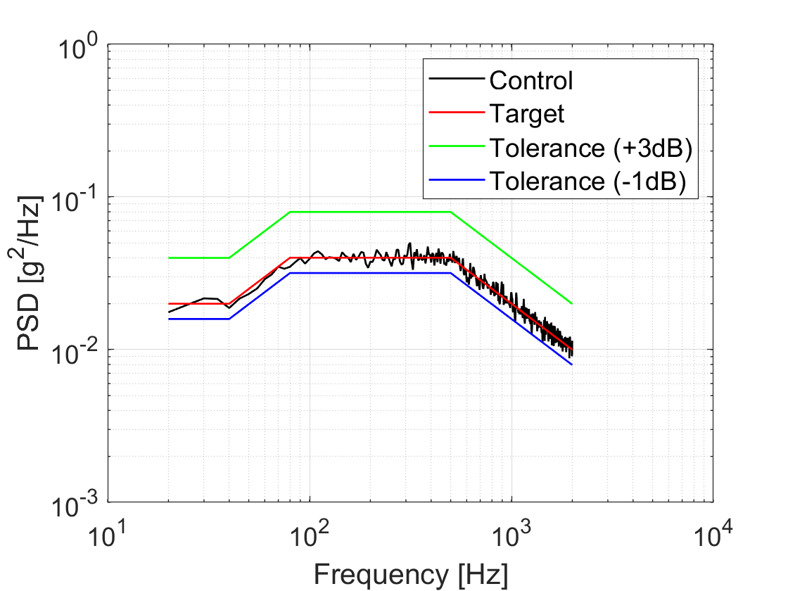

**Figure 10.1-1 PSD pattern for random vibration AT (Z axis)**

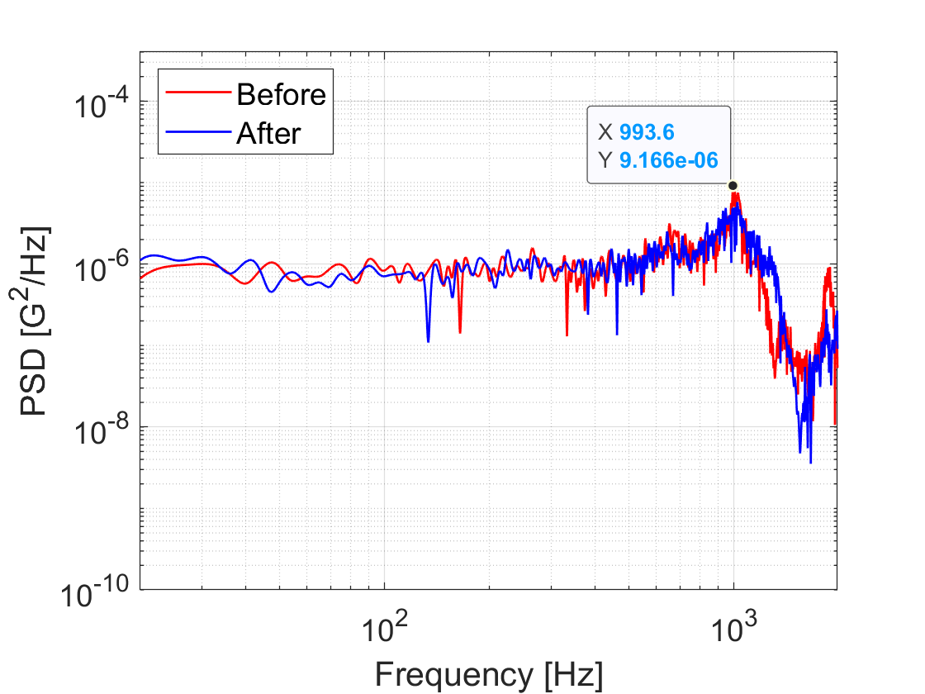

**Figure 10.1-2 Modal survey for Z axis (before and after random AT) – Point on the graph indicates 993.6 Hz, which is the natural frequency of the system**

1. Figures 10.2-1 to 10.2-2 show control data and excitation results of the exciter during X axis excitation.

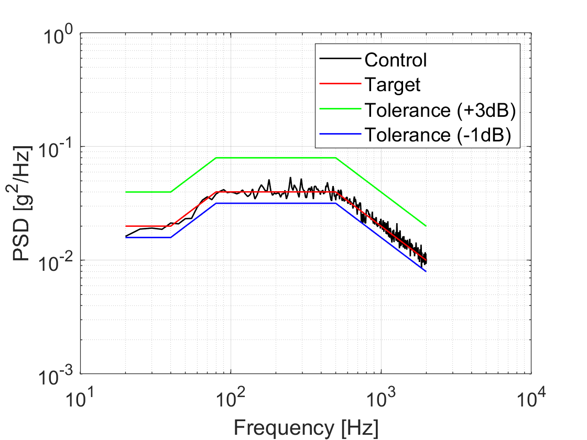

**Figure 10.2-1 PSD pattern for random vibration AT (X axis)**

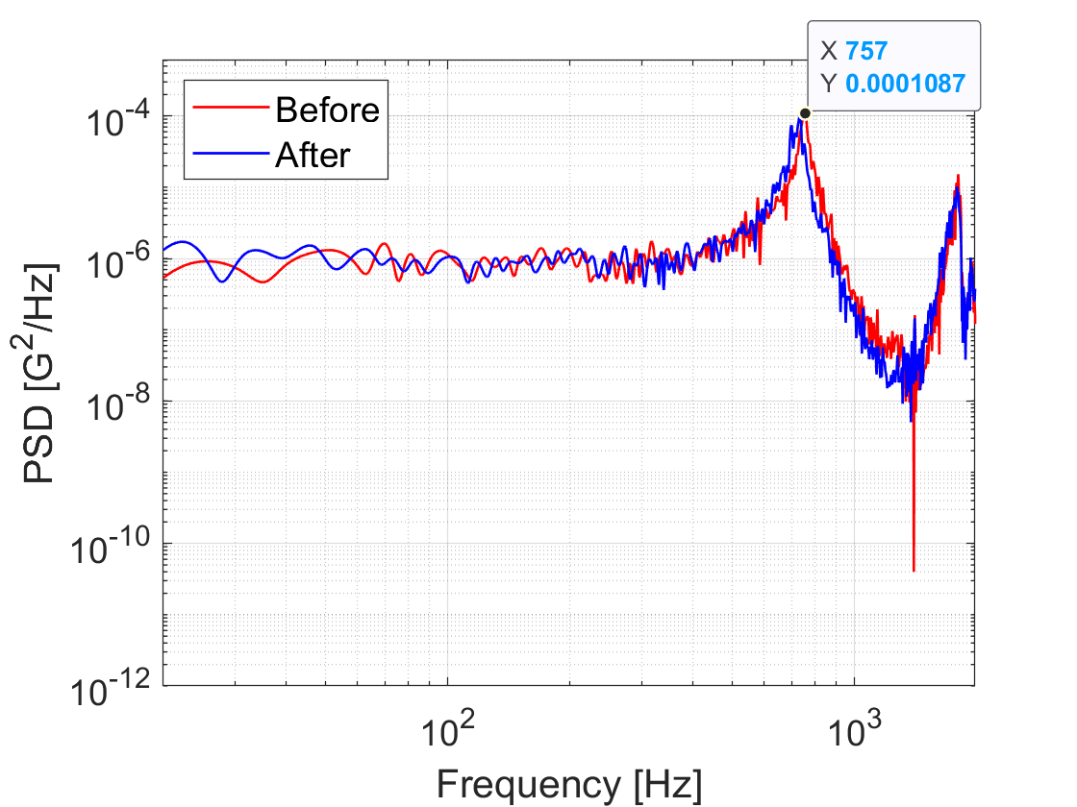

**Figure 10.2-2 Modal survey for X axis (Before and after random AT) – Point on the graph indicates 757 Hz, which is the natural frequency of the system**

1. Figures 10.3-1 to 10.3-2 show control data and excitation results of the exciter during Y axis excitation.

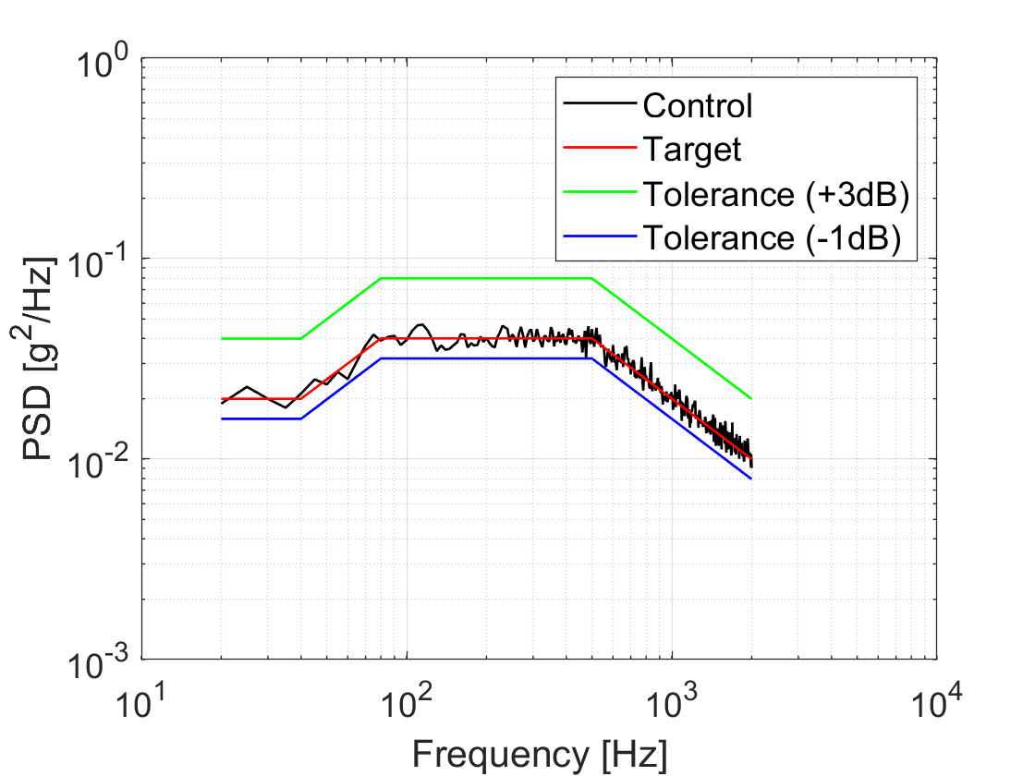

**Figure 10.3-1 PSD pattern for random vibration AT (Y axis)**

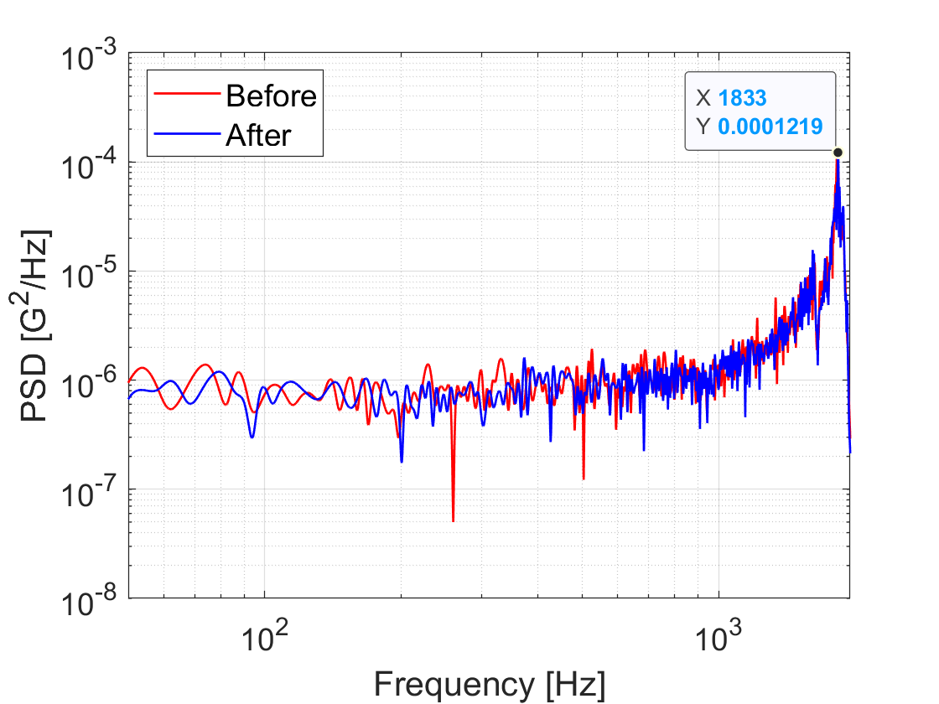

**Figure 10.3-2 Modal survey for Y axis (Before and after random AT) – Point on the graph indicates 1833 Hz, which is the natural frequency of the system**

1. Conclusion

In this test, we could perform the vibration test at the correct level.

During the vibration test, natural frequency of POD including satellites was almost the same, with no significant shift.. There was no shift in torque marks at any time during the testing, confirming the structural integrity of the fasteners used. Moreover, the deployable dipole antennas remained constrained at all times during the vibration. Fracture critical parts such as camera lens and solar cells were not broken during the vibration based on visual inspections conducted after the vibration tests.

In conclusion, the results of the vibration test show that GuaraniSat-1 has successfully passed all requirements and is ready to launch.